· **Create the** createDirectories.sh **script** to create directories based on arguments.

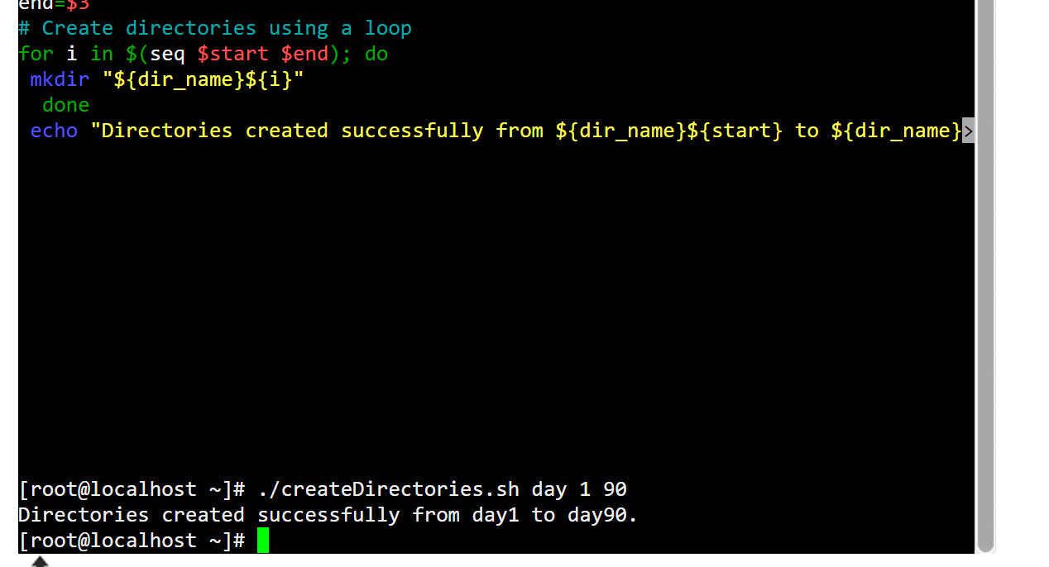

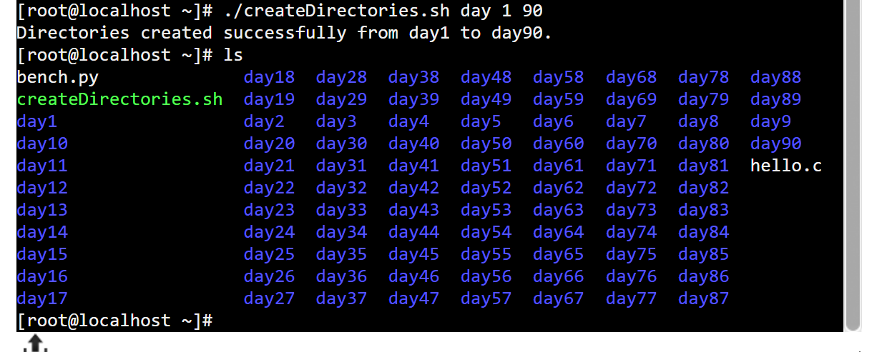

Now for movies we run 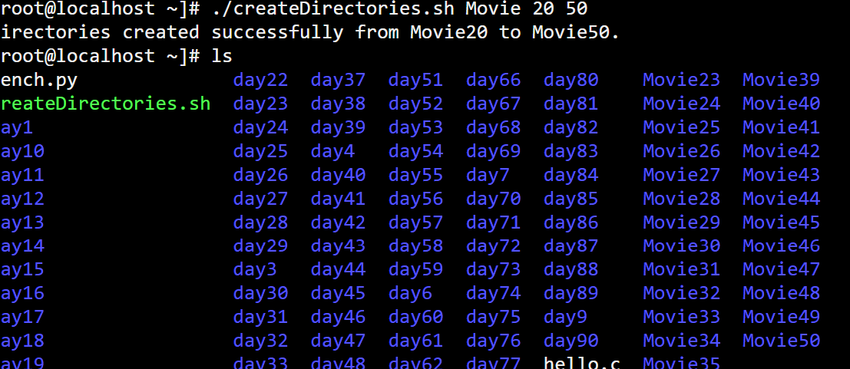

· **Create the** backup.sh **script** to backup files.

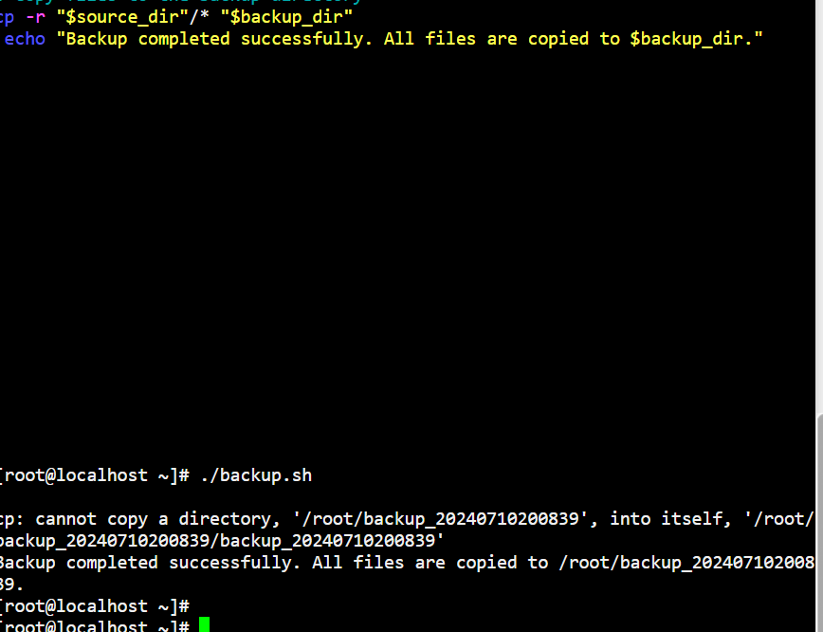

· **Schedule the backup script** using cron.

1. Open the crontab editor: **crontab -e** after that run 0 0 * * * /path/to/your/backup.sh

· **Create two users** and display their usernames.

Create the users by using these command

**sudo useradd user1**

**sudo useradd user2**

To display we use these

**cut -d: -f1 /etc/passwd | tail -n 2**

